Private Howard Nutt
146th Combat Engineer Battalion
Omaha Beach

Draft Registration Card
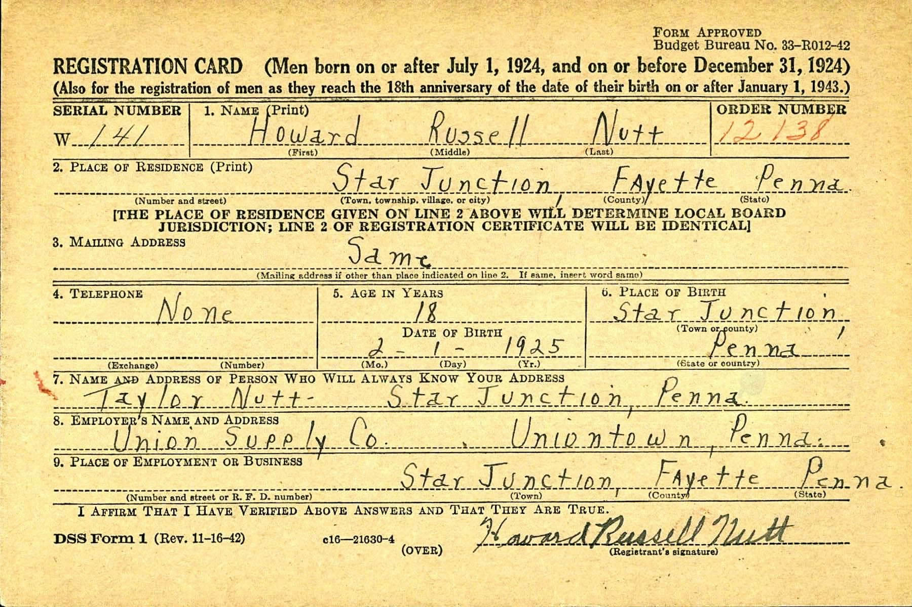

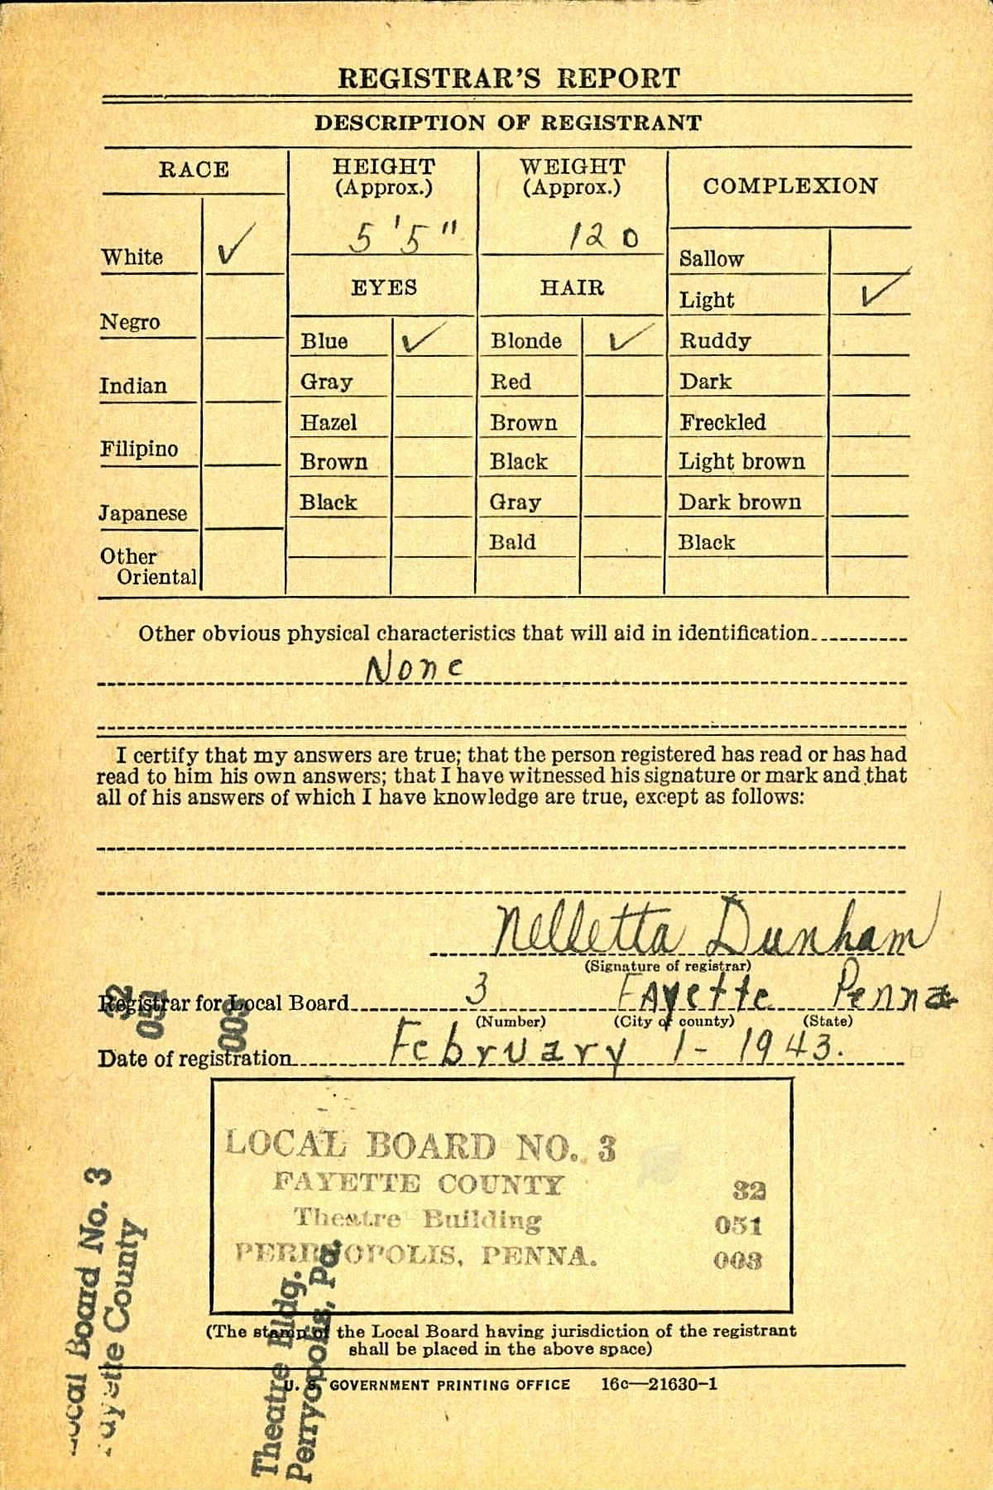

Cemetery Interment Form
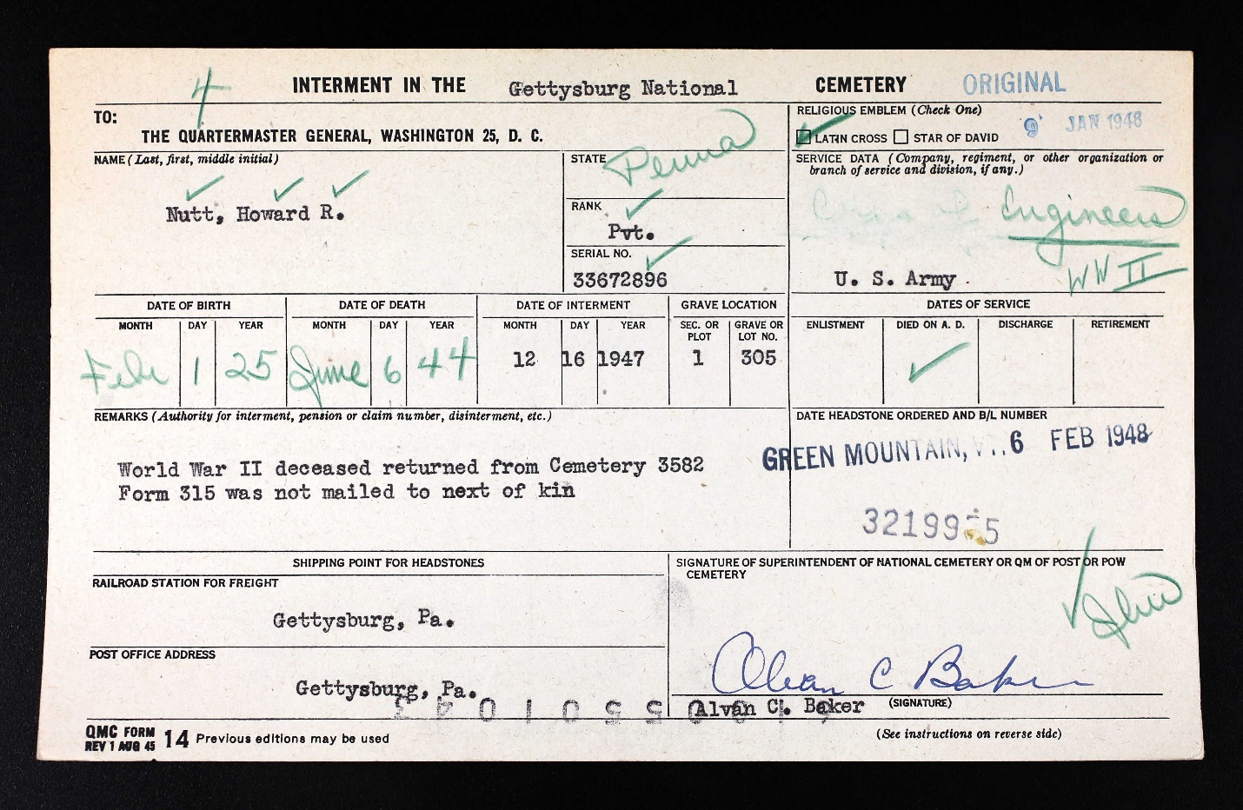

1940 Census
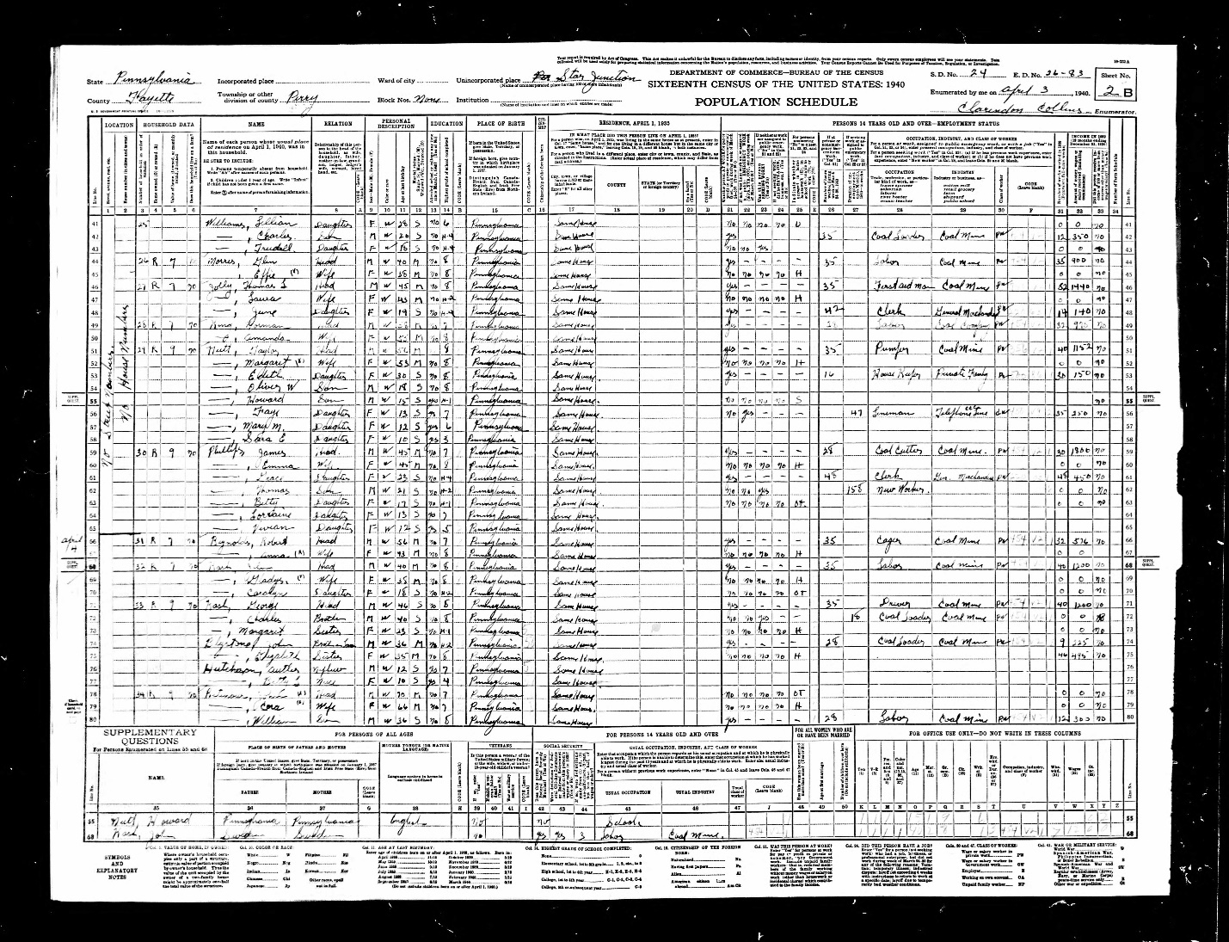

The Uniontown Morning Herald, February 17, 1944
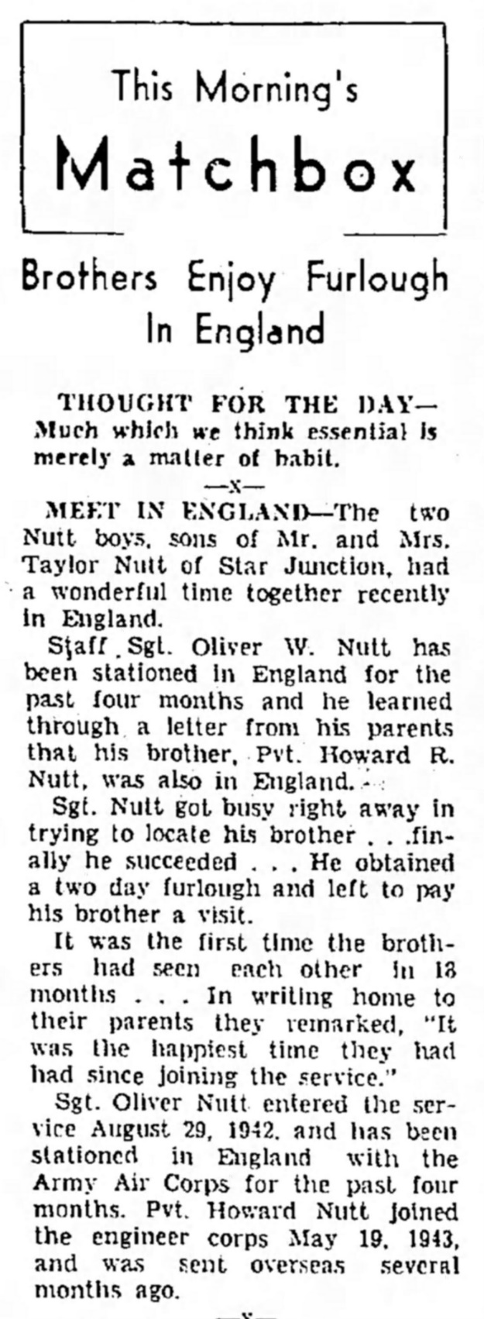

The Daily Courier, Connellsville, Pennsylvania, December 18, 1947

